My goal from the previous class session:
My goal from the previous class session was to finish merging datasets and run a simple linear regression to explore the impact of WFH on housing prices.
A concrete artifact showing progress:
- I successfully set up my project on Git Hub under the guidance of Professor Andrew.
- This week I have almost completed the data-merging and ran a linear regression to identify the initial causal relationship between working from home and housing prices. Below is my first statistical table from my analysis:

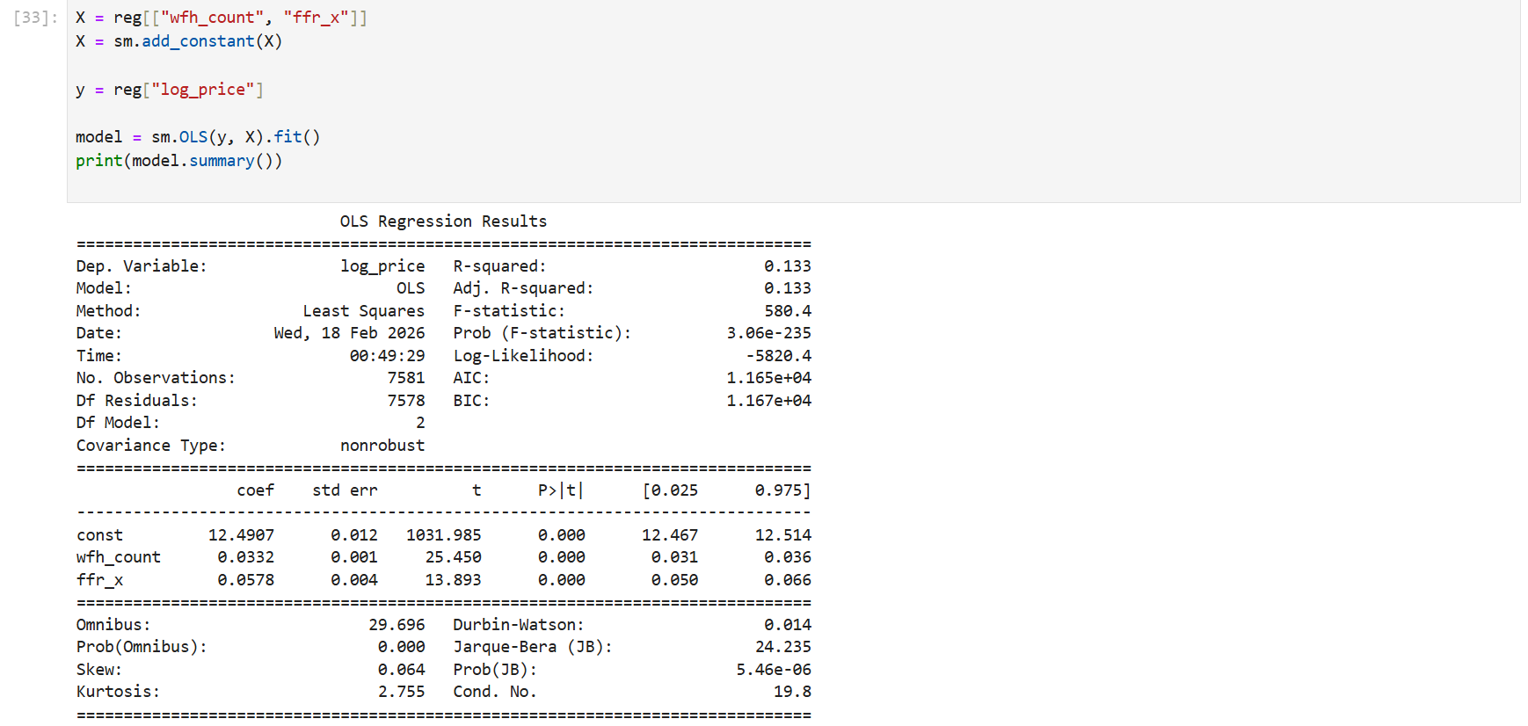
A reflection:
- The most important step, which is merging data, has been completed at 90%. The initial result showed a statistically significant effect of working from home on housing price. As the statistical table above, every percentage of working from home increases lead to an increase of 0.03 on the housing price.
- For the next step, I am exploring the “contdid” which is used for continuous treatment variable to apply for my study. I plan to include county and year fixed effect to examine the impact within county changes over the years.
- The most challenging task this week was matching working from home rate with Zillow data. Working from home is measured yearly while the housing prices are observed monthly. I’ll ask prof. Andrew whether it’s appropriate to assign yearly working from home rate to monthly housing price.
Question:
If you encountered this data frequency mismatch, would it be appropriate to assign annual WFH rates to monthly housing prices? What potential risks might this approach pose for identification and inference?

